Khadija-Tul-Kubrra

FA19-BSE-101

Assignment 2

Question:

Part 1:  
Netscape’s wants to improve their code quality which messed up. So they want to re-write code from scratch, which really a big mistake for Netscape’s.

Part 2 and 3 answer: 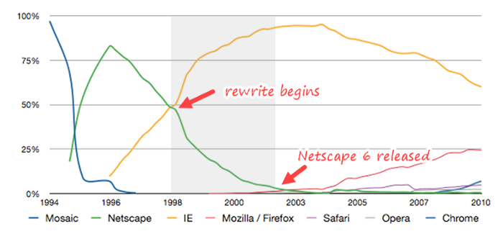

Re-write start from 1996 and going so on

But before re-write, Netscape’s Navigator, first released in 1994, defined the early years of the commercial internet.

Netscape downfall with re-write work:

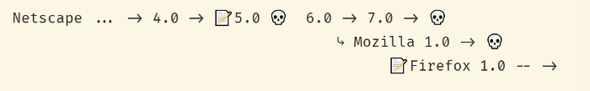Netscape’s disastrous 5.0/6.0 rewrite is the original poster child for “never rewrite”, thanks to Joel.

How:

After version 4.0 of Netscape was released, the company announced that version 5.0 would be given away for free and developed by an open-source community created and funded by the company, called Mozilla. But the Netscape team concluded that one reason outside developers wasn’t interested in contributing to their open-source project was that the existing codebase was a mess:

The code was just too complicated and crufty and hard to modify, which is why people didn’t contribute … which is why we switched to the new layout engine. A cleaner, newly designed code base, so the theory went, was going to be easier for people to understand and contribute.

So after a year the group decided to scrap their work on 5.0 without releasing it, and started from scratch on version 6.0. Another two years went by before Netscape 6.0 was finally released; even after all that time, it was clear that it was still not ready to be released.

So, after applying re-write strategies still Microsoft would end up with the remains of Netscape’s intellectual property after a 2012 deal with AOL.

Re-write wasn’t a disaster. Netscape’s slide into irrelevance wasn’t entirely due to the rewrite — a court agreed that Microsoft had deliberately abused their monopoly.

But the rewrite was certainly a contributing factor, and the end result was the destruction of a company worth billions of dollars and thousands of layoffs. So I’m going to agree with Joel that the net consequences of this rewrite were disastrous.